Practical 6
Aim : Implement Smart contact and run it using application tool.

Smart contracts:
A smart contract is a self-executing computer program stored on a blockchain. It contains predefined rules and conditions, and automatically performs actions when those conditions are satisfied. Smart contracts eliminate the need for intermediaries and provide transparency, security, and automation.
Smart contracts are commonly written using programming languages such as Solidity and are used in applications like cryptocurrency transactions, supply chain management, banking, voting systems, and digital asset management. Once deployed on a blockchain, the contract operates according to its programmed logic and its records are difficult to alter.

Steps :
Step 1: Open Remix IDE
Open the Remix website:
https://app.remix.live/
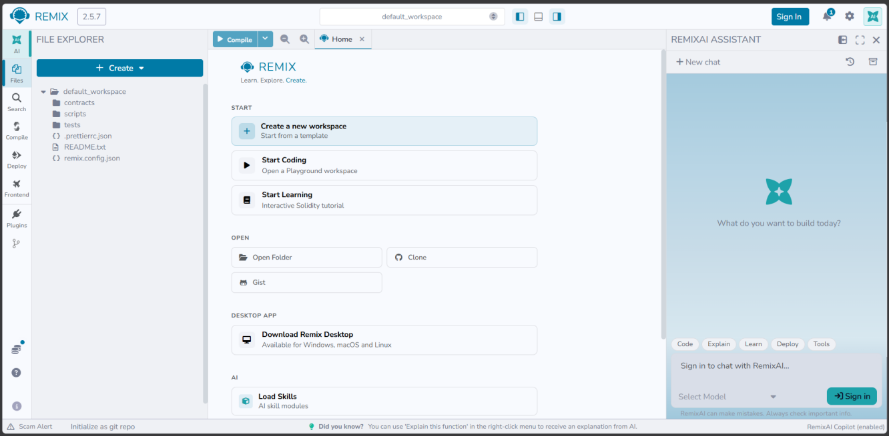
Step 2: Create a Solidity File
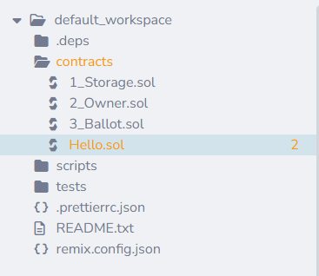
Step 3: Write the Smart Contract
Enter code:
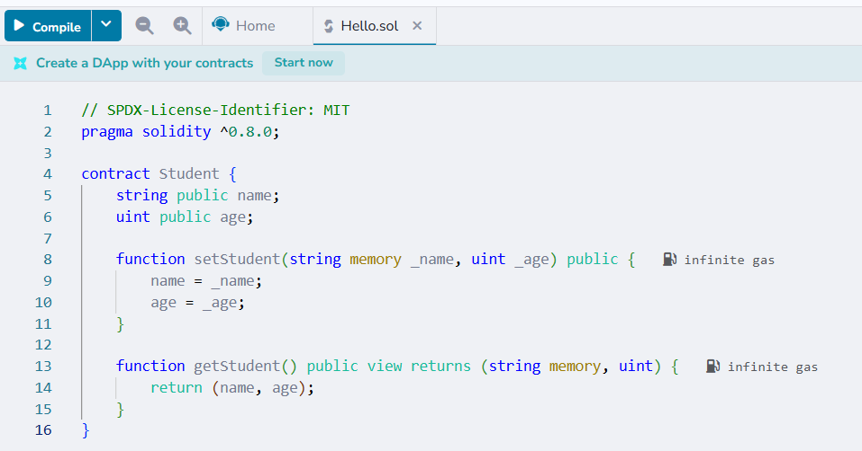

Step 4: Compile the Contract
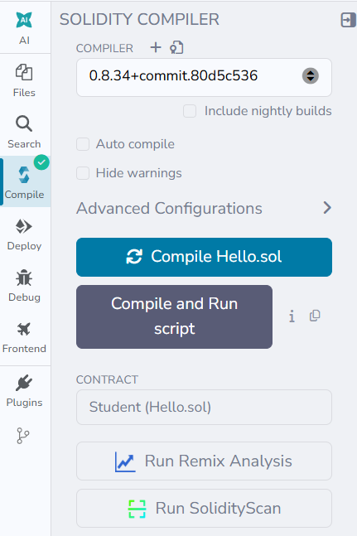
Step 5: Deploy the Smart Contract
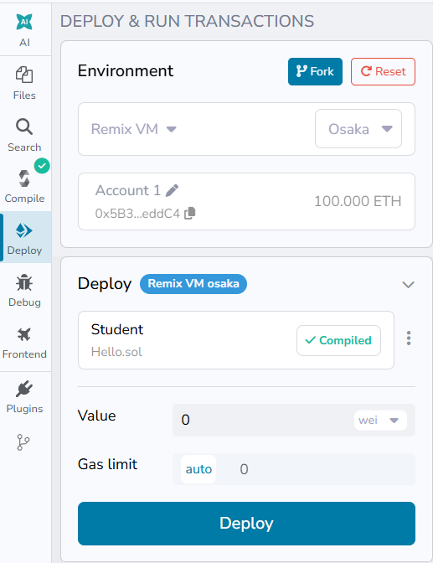
Step 6: Run the Smart Contract
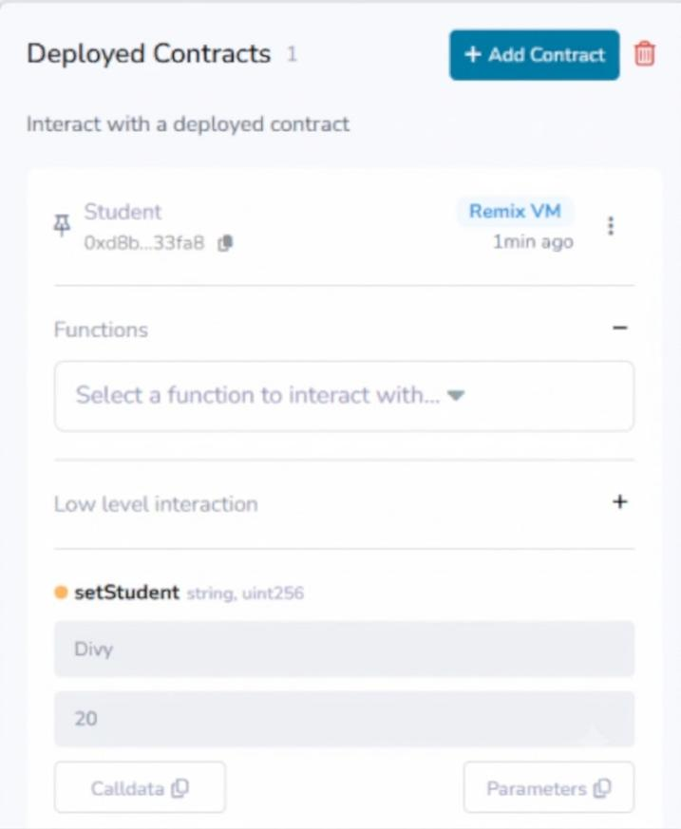

Click Transact
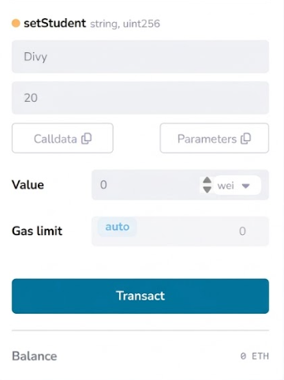
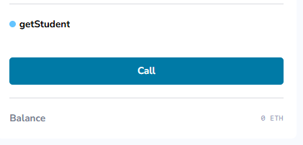
Click Call
